**Md. Maruf Rayhan**

**Reg: 232-35-623**

**Id: 0242320005341623**

**Section: 41-J2**

**Assessment – 02**

**Date: 07.09.2024**

**Question - 01:** ***Write a C program that prints all prime numbers between 1 and 100. Use a for loop to check each number and print only those that are prime.***

**Code:**

**#include <stdio.h>**

**#include <math.h>**

**int main()**

**{**

**printf("Printing prime numbers from 1 to 100\n");**

**for (int i = 2; i <= 100; i++)**

**{**

**int isPrime = 1;**

**for (int j = 2; j <= sqrt(i); j++)**

**{**

**if (i % j == 0)**

**{**

**isPrime = 0;**

**break;**

**}**

**}**

**if (isPrime)**

**{**

**printf("%d\n", i);**

**}**

**}**

**return 0;**

**}**

**// Author: Md. Maruf Rayhan :D**

**Attachments:**

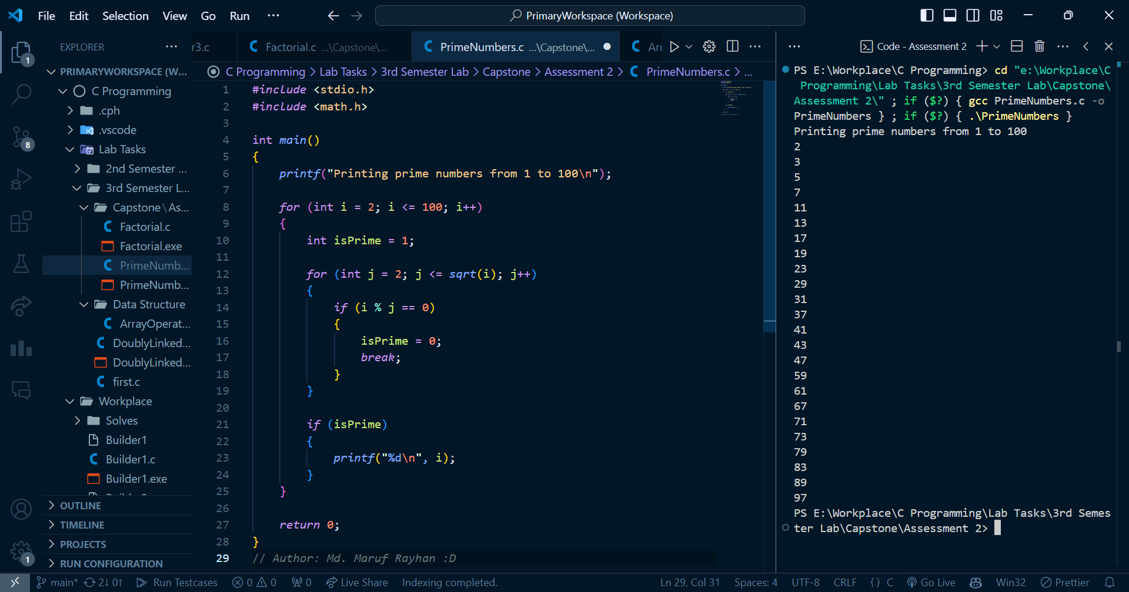

**Question - 02:** ***Write a C program that calculates the factorial of a given number n using a while loop. The program should prompt the user to enter a positive integer and then display the factorial of that number.***

**Code:**

**#include <stdio.h>**

**int main()**

**{**

**int n;**

**printf("Enter the number to find the factorial: ");**

**scanf("%d", &n);**

**int factorial = 1, i = 1;**

**while (i <= n)**

**{**

**factorial *= i;**

**i++;**

**}**

**printf("Factorial of %d is %d\n", n, factorial);**

**return 0;**

**}**

**// Author: Md. Maruf Rayhan :D**

**Attachments:**

